 Pegasys
[Credit Card- Generate Credit Card Log Transactions Reports]

- CRCD Log Transactions—Generates a listing of all Pegasys Credit Card Log (CL,CT) transactions
that have been entered in Pegasys, organized by Approving Official, date, and reconciliation status.
The Approving Official, Credit Card Alias, Date Range, and Reconciliation Status (All Logs or
Unreconciled Logs only) are the parameters entered to generate this report. Note: The Date Range is a
required parameter. The Approving Official and the Credit Card Alias must be entered in the exact
format as shown below. The date range must be entered in the MM/DD/YYYY format. Status can be
selected from a drop-down menu.
Figure 1
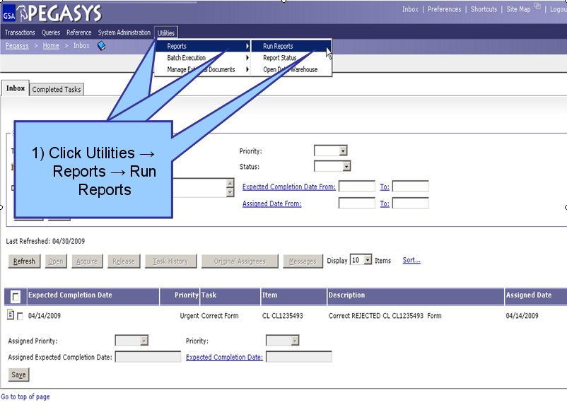
Figure 1

- From the Pegasys homepage, click on Utilities on the Menu Bar
- Click on Reports.
- Click on Run Reports.

**View Reports page is displayed for all available reports**
Figure 2
Figure 2

- Click the “+” box next to the Credit Card folder to expand this folder. (Step 1)
- Click the “+” box next to the Reports folder to expand this folder. (Step 2)
- Click on CRCD Log Transactions L once to highlight this report. (Step 3)
- Click the Select Report button after the report is highlighted. (Step 4)
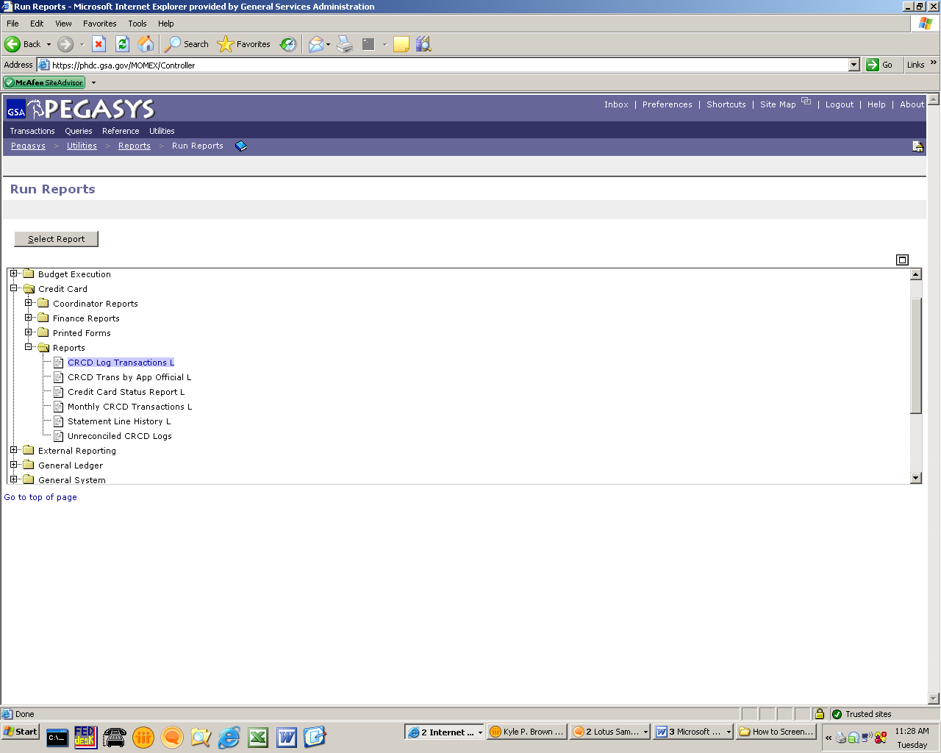
4) Click Select
Reports
1) Click Credit Card
2) Click Reports
3) Click CRCD Log
Transactions
(OVER)

Figure 3
Figure 3
- Enter in the Cardholder’s Alias. (Step 1)
- To narrow down the search parameters for your report, enter a specific Date Range. (Step 2)
- Click Run when finished. (Step 3)

**If the report has been generated, a message display will appear under the breadcrumbs track that says, “The report has been successfully submitted.”**
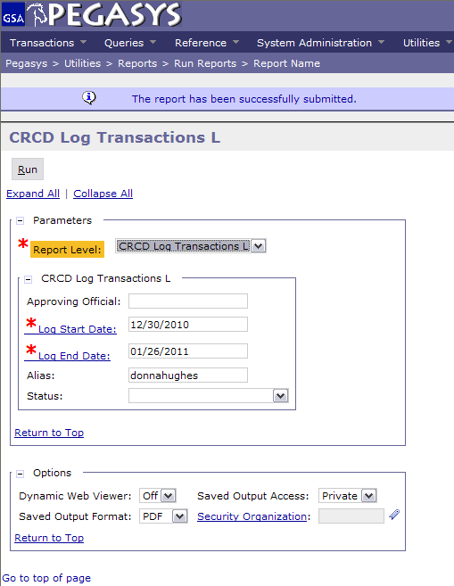
1) Enter Alias
2) Enter Start and
End Date
3) Click Run

Pegasys
[Credit Card- View Credit Card Log Transactions Reports]

- CRCD Log Transactions—Generates a listing of all Pegasys Credit Card Log (CL,CT) transactions
that have been entered in Pegasys, organized by Approving Official, date, and reconciliation status.
The Approving Official, Credit Card Alias, Date Range, and Reconciliation Status (All Logs or
Unreconciled Logs only) are the parameters entered to generate this report. Note: The Date Range is a
required parameter. The Approving Official and the Credit Card Alias must be entered in the exact
format as shown below. The date range must be entered in the MM/DD/YYYY format. Status can be
selected from a drop-down menu.

Figure 1
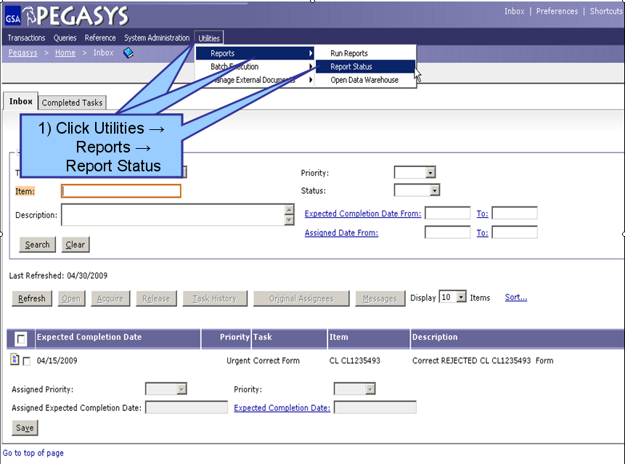
Figure 1

- From the Pegasys homepage, click on Utilities on the Menu Bar
- Click on Reports.
- Click on Report Status.

**Report Status Maintenance is displayed for all processing and/or completed reports**

Figure 2
Figure 2

- To find a report, the user can search by Report Subsystem. Enter all known information. (Step 1)
- Click Search. (Step 2)
- When the results are returned, select a report from the populated field. (Step 3)
- Click Details after the report is selected. (Step 4)
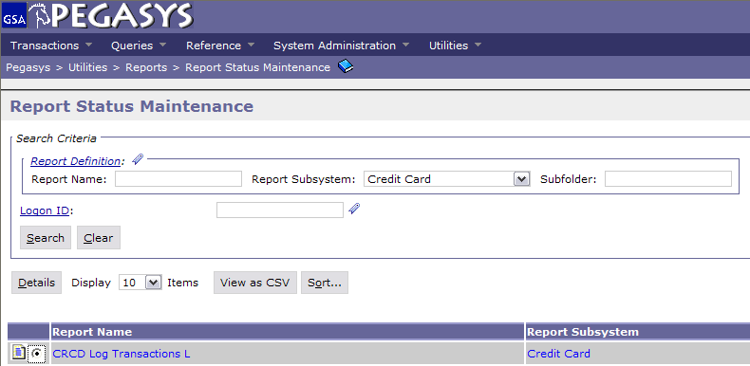
1) Search by:
Subsystem
2) Click Search
3) Select the Report
4) Click Details
(OVER)

Figure 3
Figure 3

- On the Report Executions page, select the report to be viewed. (Step 1)
- Click Output after the report has been selected to view the report as a PDF file. (Step 2)

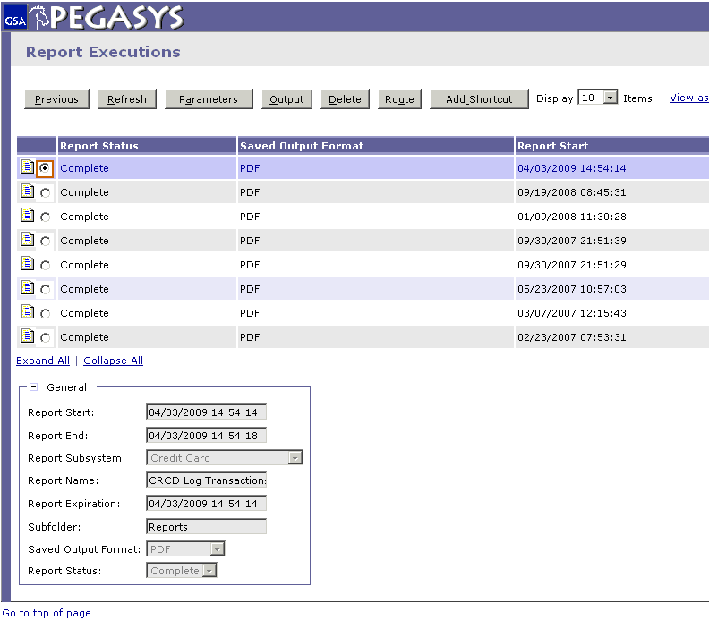
2) Click Output
1) Select the Report

